PROFESSIONAL DEVELOPMENT AIMS 2015
In line with the Strategic Plan and Charter the aim of professional development at Waikanae School during 2015 has been:
- To continue to raise student achievement for all students with a particular emphasis on Priority Leaners

This focus is a continuation of the work that was undertaken in 2014

In order to do this there were several focuses:

- Embedding Teaching as Inquiry Cycle into everyday practice
- Identifying and planning specific programmes for our priority within the classroom setting
- Develop a greater understanding of Tātaiako and its use within the teaching and learning setting
- Continue to develop staff competency in teaching Science

As the year developed it also became apparent that a Waikanae School Curriculum document needed to be developed and this was then incorporated into Staff Professional Development time.

TEACHING AS INQUIRY
As outlined in 2014 the Teaching as Inquiry Cycle was used to underpin the professional development foci this year
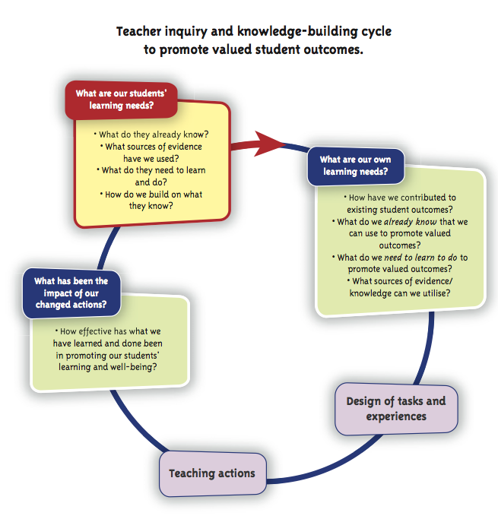
Following on from the work we did in 2014 the focus of Professional Development remained around changing practice to shift student achievement. In contrast to 2014, our Priority Learner Plans were based around the topic of writing and were conducted in professional learning groups rather than individually. These groups consisted of 4 teachers, teaching students of a similar age. Using a work sample groups identified and area to focus on and as a group develop a Priority Learner Plan using data to show progress and change at the end of the intervention. The intent was also to try and incorporate the plan as seamlessly as possible into an everyday programme rather than it seeming like an ‘add on’.

By working as a group teachers were able to share ideas, success and things that had not gone so well. The groups were able to think together to find ways to develop assessments that were able to measure progress in a clear way. This was an area that needed addressing as identified at the end of 2014.

UNPACKING TĀTAIAKO

Our next focus of the year was to unpack the Tātaiako document. The Tātaiako document outlines the Cultural Competencies that all teachers and leaders are expected to demonstrate in their schools and classroom to support Māori learners. The work we did around the Cultural Competencies was led by Lynette Bradnam on a Teacher Only Day followed by some staff meetings.

There are 5 Cultural Competencies in all and we chose to focus on two:
- Ako – Taking responsibility for our own learning and that of Māori Learners
- Manaakitanga – showing integrity, sincerity and respect towards Maori beliefs, language and culture

During our Teacher Only Day we unpacked these two competencies, building our own knowledge of what they meant and what they meant for our Māori learners. Staff were expected to think about one of these competencies and create an action plan of what they were going to do in order to ensure that it was being demonstrated in the classroom and beyond.

In following professional development, staff were asked to identify specific students that were at risk and what our concerns were. Following the inquiry cycle, teacher’s developed individual plans that would address what they had identified using the competencies of Manaakitanga and Ako as a basis for their plan. It challenged thinking and staff thought carefully about what they were going to implement within their classrooms to support their Māori learners.

RTC EVIDENCE LOG
An evidence log for teachers to record practise and documentation to support Registered Teacher Criteria and Appraisal expectations was established. Staff meetings were spent unpacking what the Registered Teacher Criteria statements meant and the types of information that could be included in their document as evidence of meeting these. Staff are now adding to them regularly to show evidence of them meeting the RTCs and Cultural Competencies. They are used as part of the school appraisal process. The leadership team also have a leadership component to their document.

SCIENCE
This year a further 4 teachers attended the Sir Paul Callaghan Science Academy at the end of Term 2. A staff meeting around the language of Science was held and a vocabulary bank was created with staff.

LEADERSHIP
All of the leadership team attended a course this year based around developing our leadership practices. It was an excellent course over four days that strengthened our skills as leaders. Much of the work was theory based but had a practical application. This is already being using when working with syndicates and staff back at school.

