WHO ARE SPECIAL NEEDS CHILDREN?
Special Needs Students are those children who are:
- Receiving support from outside agencies
- Those at risk’ receiving teacher aide support
- Gifted and talented students
This report outlines the additional support we give to our students with special needs. It is important to note that the classroom programmes teachers run are differentiated and as such cater for some of the diverse needs of our learners.
IDENTIFYING SPECIAL NEEDS CHILDREN
There are a number of ways in which we identify children with ‘special needs’. These include using our existing knowledge of the children and their learning needs alongside assessment results and learning records.
A register of our special needs students and those who are ‘at risk’ in terms of learning are kept on our school management system. The use of our OTJs helps indicate students who are underachieving along with standardised testing for students in years 4-8. These tests include, STAR, PAT Reading Comprehension and Vocabulary and Maths. Students who are stanine 4 or below also have their progress monitored throughout the year.
For children in Year 1-3 their reading development is tracked using a ‘reading wedge’ and information is gathered through the use of running records. Those children whose progress is cause for concern are identified. Children who are making the least progress and are 6 years old are identified for Reading Recovery.
The needs of the child (and the amount of funding available) dictate the types and amount of support the child receives.
REFERRALS AND APPLICATIONS
All referrals are made through the SENCO. This ensures that there is a clear understanding of the Special Needs within the school, the agencies involved and the communication occurring with regard to these. It also allows the right match between the student’s needs and the appropriate agency. Referral forms for the different agencies are kept online or with the SENCO. Some of the agencies that we liaise with are
RTLB – Resource Teachers of Language and Behaviour
RTLit – Resource Teachers of Literacy
GSE – Group Special Education
SLT – Speech Language Therapists
OT – Occupational Therapists
KSCT - Kapiti Safer Community Trust
INTERVENTIONS AND SUPPORT
ORS Funding
This funding is designed for children with severe special needs. It involves and long and arduous application process. We currently have four students who are ORs funded. This allows us to provide teacher aide support enabling them to function successfully in the classroom. Two students are in the senior school and two are in the junior school. We have engaged a specialist teacher to work with the students for 30 minutes per day for 3 days per week.
RTLit
Four students have received RT:Lit support this year. Janet Hunter is the RT:Lit teacher and she has worked directly with the students. All four students on her roll have been rolled over to receive continued support in 2016. Her assessment of each student is as follows:
Names | Reading Level Pre Intervention  (Year level expectations) | Reading level Post Intervention or at the end of the year  (Year level expectations) | Status
Waikanae
Student 1 | More than 2 years below | More than 1 year below | Rolled over to 2016
Student 2 | More than 2 years below | More than 1 year below | Rolled over to 2016
Student 3 | More than 2 years below | 6 months – 1 year below | Rolled over to 2016
Student 4 | More than 2 years below | More than 1 year below | Rolled over to 2016

RTLB
9 students have gone through the RTLB service this year. 4 of the students have been closed off the RTLB roll. 5 students still remain on the roll and will be carried through to 2016. Many interventions and supports have been put in place in conjunction with the RTLB advisors. IEP meetings are held with RTLB, other outside agencies, staff, parents and the SENCO to establish learning or behavioural goals, identify successes and discuss any issues.
SLT
1 NE student came to school on the SLT roll but the file has since closed. We have had no further applications for SLT and no students are on the roll.
READING RECOVERY
Over the past year 10 students have received Reading Recovery. 4 of these students were carried over from 2014. The programme involves a daily 30 minute session with a reading recovery trained teacher. Amanda Boyes is our trained Reading Recovery Teacher. Of these 10 children, 6 have successfully completed the programme and have been discontinued. 4 students are being carried over into 2015. For a more detailed summary of the children’s achievements see the Reading Recovery report for 2015.

In School Interventions
A number of in school interventions have taken place in 2013 and a Rationale and Aims for each programme have been attached to this report. Many interventions involved individual students this year.
Lexia
Over the course of the year 8 students have been targeted through the use of the Lexia programme. The programme auto places the student at the correct level and students work through tasks with different focuses and progress through the levels. Levels cover the following skills:
- Phonological Awareness
- Phonics
- Structural Analysis
- Fluency
- Vocabulary
- Comprehension
Students are required to master a number of these skills in order to progress levels.
The progress of each student undertaking the Lexia Programme is outlined below:
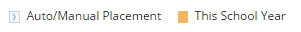
Student 1 – Year 4
Auto placed at Year 2 level, currently working at Year 3 level.
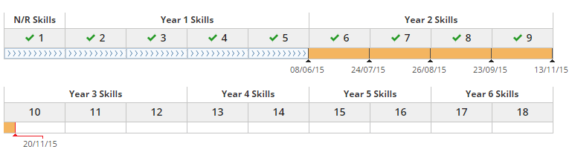

Student 2 – Year 5
Auto placed at Year 2 level, currently working at Year 2 level.
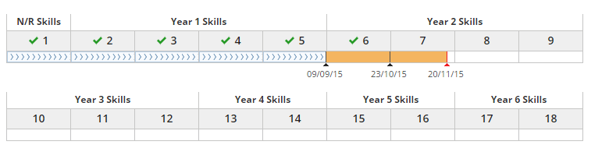
Student 3 – Year 4
Auto placed at Year 2 level, currently working at Year 2 level.
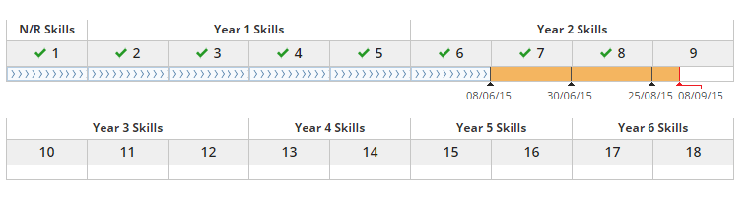
Student 4 – Year 8
Auto placed at Year 2 level, currently working at Year 5 level. This student began Lexia last year.
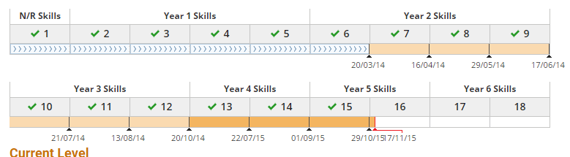

Student 5 – Year 2
Auto placed at Year N/R level, currently working at Year 2 level.
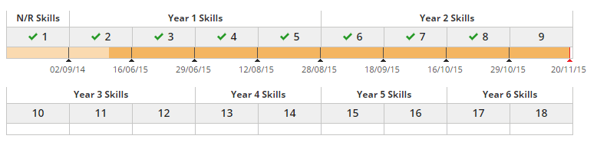
Student 6 – Year 5
Auto placed at Year 1 level, currently working at Year 2 level.
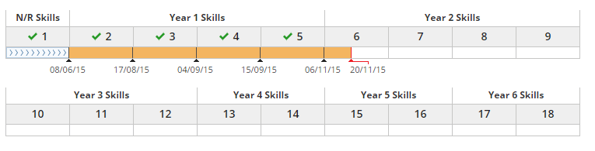
Student 7 – Year 8
Auto placed at Year 2 level, currently working at Year 4 level. This student began the programme last year.
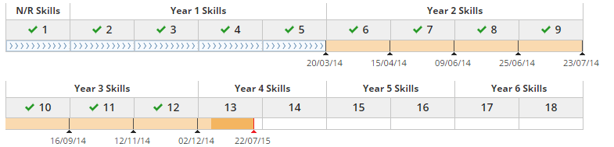

Student 8 – Year 3
Auto placed at Year 2 level, currently working at Year 4 level.
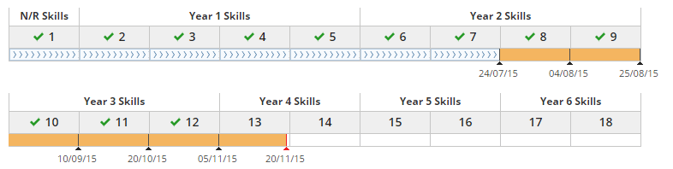

Individual Students
Kim Aitken has been working with 5 individual students, 4 of these are long term and have been supported for the whole year. These students have made small amounts of progress. Unfortunately at the time of writing this report there is no explicit data to show the amount of progress made. Data will be collated at the beginning of 2016 to show any progress made.

Talk to Learn
This oral language programme was run for 5 of our students. It included students with speech, language difficulties and English as and additional language.

TEACHER AIDES
There are currently four teacher aides employed. A breakdown of their responsibilities is outlined below.
Kim Aitken works a number of children from year 1-8 and is highly skilled in literacy programmes. She works with individuals and groups of children and the children she supports are reviewed once a term. This year Kim has supported children in a variety of ways.
- Supported individual children and groups in reading and writing
- Worked with ELLs students on reading and writing skills
- Provided support for students on the RTLB and RT:Lit roll
- Carried out oral language programmes
- Run the Lexia programme to support literacy learning with a small group of students
Although not classed as special needs, Kim has also worked with English Language Learners supporting the acquisition and understanding of the English Language.
Marie Wahren works from 9am – 12pm. She works with one of our students with very high needs during the morning. This term Marie has also supported the Room 8 class teacher with the very large New Entrant class from 1.30pm-3pm.
Vanessa Johnson works from 9am – 3pm with one of our very high needs students. She works within the classroom and supports in adapting and developing stimulating activities that enable these students to have access to the curriculum.
Karen Noakes works from 9am-3pm with one of our ORs funded students. She works within the classroom and supports in adapting and developing stimulating activities that enable these students to have access to the curriculum.
Andrea Breu works from 9am-12.30pm with one of our new ORs students.

OTHER PROGRAMMES
GIFTED AND TALENTED LEARNERS
This year there have been the following opportunities to support our Gifted and Talented Learners.
ENGLISH
Some of our talented Year 8 writers participated in a writing workshop with Osacr Kightly
MATHS
Some of our Year 7 & 8 students participated in Otago Maths Problem Solving Challenge

PERFORMING ARTS
Music
Andrea Boon has worked with a group of Year 6, 7 and 8 students on two school bands. The band has performed at assemblies and school discos.

TECHNOLOGY
Tech Team
There are a small group of students who organise technology equipment for assemblies and discos.

LEADERSHIP
School Council
Two students in each class from year 2 and above are elected school councillors by their peers. They help organise school events such as assemblies and wheels day. They participate in these activities as required.

Disco and Formal Committees
A group of senior students have been involved in organising the discos and the Year 8 formal.
Young Leaders Day
A group of Year 7 and 8 students attended Young Leaders’ Day in Wellington.

PHYSICAL EDUCATION
Our most talented sports people are selected for various competitive events throughout the year. The events comprise of interschool hexathlon, interschool run, jump, throw, interschool, district and regional cross country, interschool swimming, rugby, Triathlon, interschool Winter Tournament and Milo Cup cricket.

Report prepared by Michelle Banks
SENCO

