VENUE∞  Kapanui School  Rimu Road  Waikanae  ∞See schedule for additional excursion locations and times.  HOLIDAY PROGRAM HOURS  Holiday Program 7:30am - 6:00pm: Daily Rate refer below. Daily discounts is on a per week basis.  HOLIDAY PROGRAM DAILY PRICE (Over the Holiday’s)  5+Days booked- $41.00 per day  4 Days Booked - $42.00 per day  3 Days Booked - $45.00 per day  2 Days Booked - $46.50 per day  1 Day Booked - $51.00  2-5 day rates is spread over the whole school holiday period.  LARGER FAMILY DISCOUNT  If you have three kids or more in your immediate family who all want to attend our programs, then you qualify for our Discounted Rate of only $35.00 per child per day (saving over 25%, multiple day discount does not apply).  BONUS FOR EARLY ENROLMENT DISCOUNT  If you can help our administration team by getting your enrolment forms to us “at least 5 working days before” program starts, we will thank you with a BONUS 5% discount.  ENROLMENT FEE  (First time enrolment only) $5.00 per child or one off of $12.50 for 3+ children.  EXCURSION FEE*  Day trips/Alternative Venues may require a minimal extra fee. Please check relevant days on activity schedule and/or enrolment forms |  | CYF APPROVED  All KidzOwn Programs are CYF approved so WINZ childcare fee subsidies are available.  HOW TO ENROL  You can either:  - Enrol Online at www.KidzOwn.co.nz,  - Collect an Enrolment Form from one of our After School Care Programs,  - Request an enrolment via email to: info@kidzown.co.nz or  - Contact our team on 0800 543 9696  All KidzOwn Policies & Procedures apply and can be found on our website.  * | 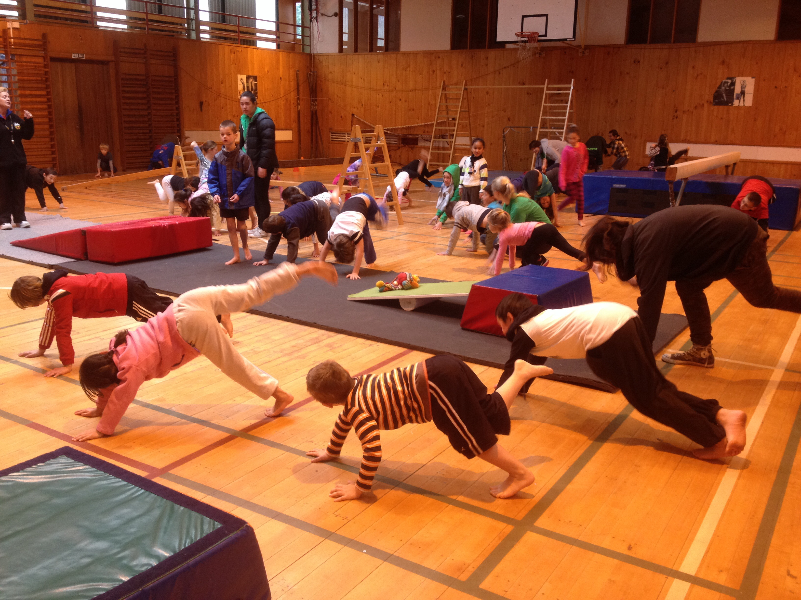  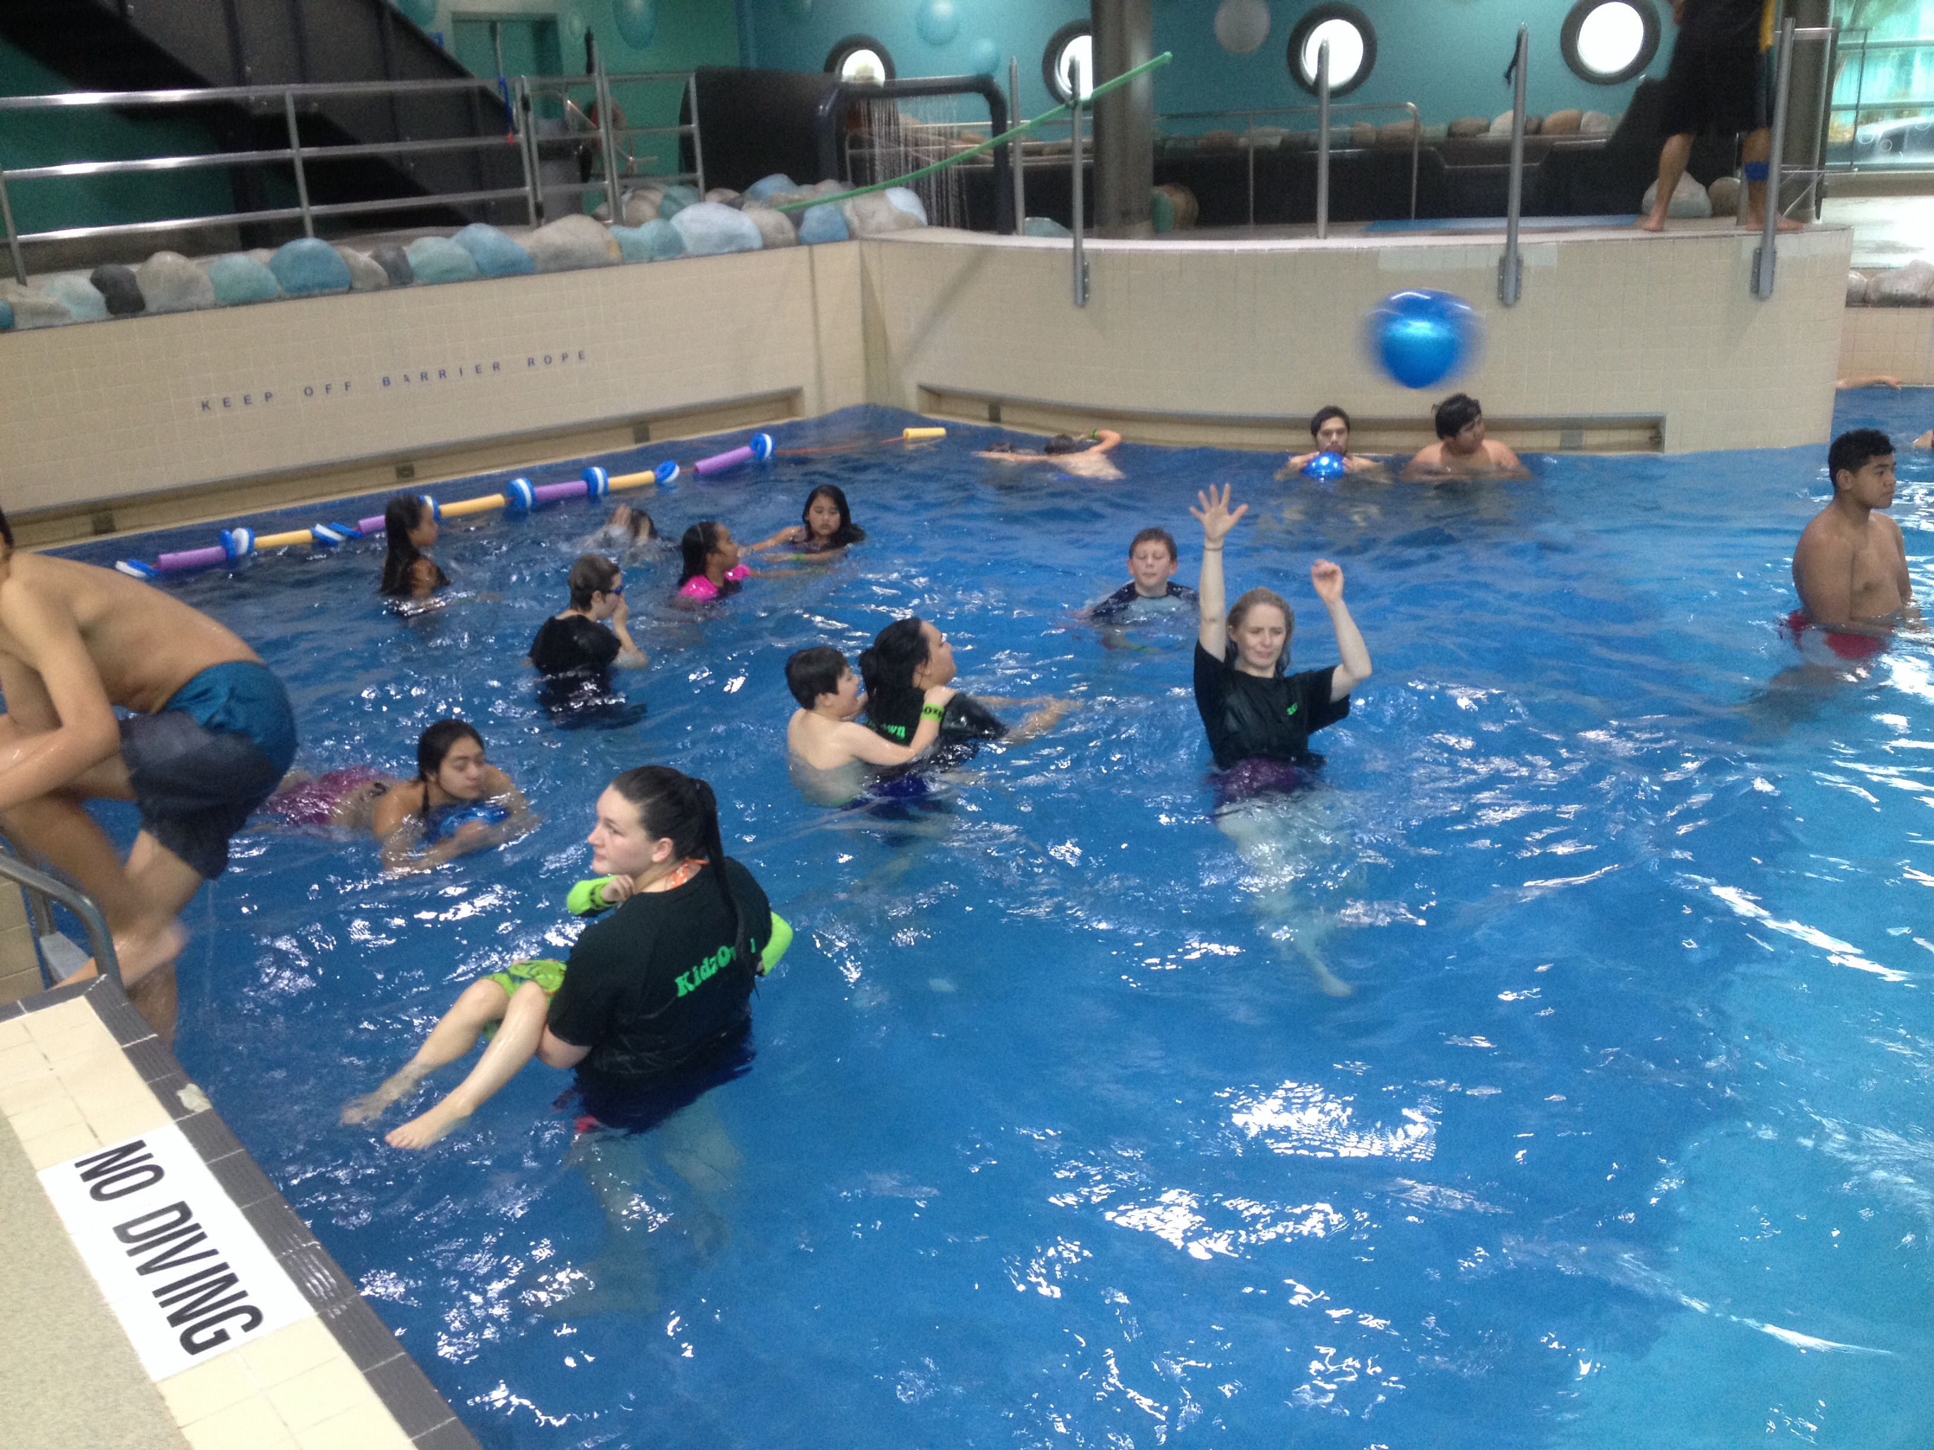  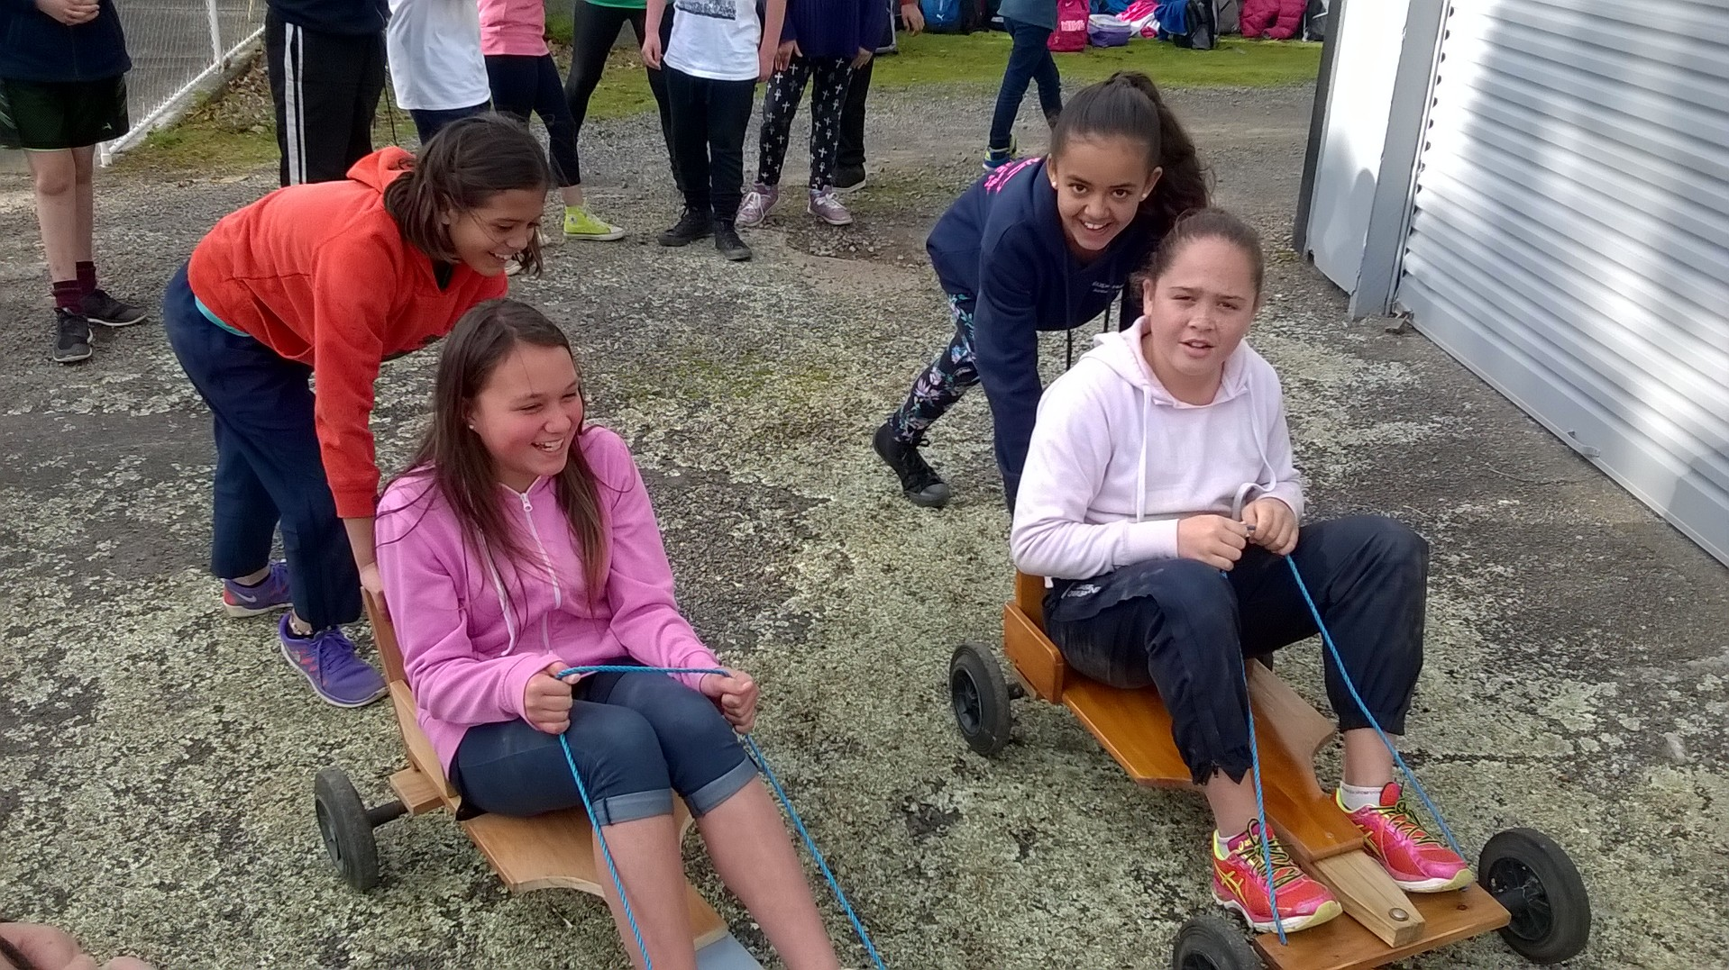 |  | WAIKANAE  Autumn School  Holiday Program  Monday 18th Apr – Friday 29th Apr ‘16 | Holiday Programs  Looking for something FUN & EXCITING for your children to do during the upcoming school holidays? Look no further!!  KidzOwn provides a positive, fun, safe and caring environment with a broad variety of age appropriate, action packed, child focused activities.
Waikanae Autumn School Holiday Program
MONDAY 18th APRIL – FRIDAY 29TH APRIL 2016

Holiday Programs

*Note that the stated price is in addition to our daily charge, refer to info pack for relevant prices ** Restricted Numbers
CYF approved so WINZ childcare fee subsidies are available. Enrol Online at www.KidzOwn.co.nz or Contact our friendly team on 0800 543 9696 or send an email to: info@kidzown.co.nz to receive an information pack.

JUNIORS ACTIVITIES (5-9yrs) |  |  |  |  | SENIORS ACTIVITIES (10+ yrs)
Mon 18th Apr | Tue 19th Apr | Wed 20th Apr | Thu 21st Apr | Fri 22nd Apr | Mon 18th Apr | Tue 19th Apr | Wed 20th Apr | Thu 21st Apr | Fri 22nd Apr
LET'S JOIN THE CIRCUS  Crazy Circus Fun Themed Activies & Games. | MOVIES & SKATE/TRAMP PARK - $20.00*  Watch the latest 'Kung Fu Panda 3' @ Downtown Cinemas then enjoy Loads of Bouncy Flippy Fun & You Can Bring Ya Scooters Too | BIG G'S HIP HOP DANCE WORKSHOP & GRAFFITI ART  Learn some of da latest moves and shake your stuff. Also bring along an old t-shirt and create an awesome new look | AUTUMN SPLASHTIME - $5.00*  Awesome inflatables fun, crazy splash tank onsite and fun Junior's Pool @ Otaki Pools. PLUS Sausage Sizzle | DISNEY DAY  Day stacked with loads of Disney Character themed activities and fun games | THE ULTIMATE CHALLENGE  Team vs Team. Taking on the 'Mental Mind Benders', the 'Sporty Physical' games & 'Crazy Co-Ordination Skill Testers' plus A Whole Lot of Luck. | MOVIES & TRAMP/SKATE PARK - $20.00*  Watch the newest version of Snow White 'The Huntsman: Winters War' @ Downtown Cinemas then Go Bouncy Crazy Or Bring Your Own Scooter & Rip It Up At The Skate Park | ADRENALIN FOREST & JETTY FISHING - $25.00*  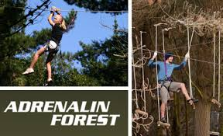  No1 for Highwire fun. Feel the fear and do it anyway. **Designed for all skill levels**. Then Go Fishing off a jetty at Paramata Boat Sheds (if raining going for lunch @ BK then fishing) | AUTUMN SPLASHTIME - $5.00*  @ Otaki Indoor Pools. Awesome Inflatables, Crazy Splash Tank onsite and fun Junior's Pool. PLUS Sausage Sizzle | COOL BAKE-A-CAKE-A-DECORATOR  Learn the ART of creative design and piping to bake a masterpiece to be eaten and enjoyed. Loads of fun challenging activities.
Mon 25th Apr | Tue 26th Apr | Wed 27th Apr | Thu 28th Apr | Fri 29th Apr | Mon 25th Apr | Tue 26th Apr | Wed 27th Apr | Thu 28th Apr | Fri 29th Apr
CLOSED | BEING A KIWI & AWESOME A.N.Z.A.C DAY ACTIVITIES  Celebrating our ANZAC past and enjoying everything about being a Kiwi. | HORSE VAULTING CLUB & PETS DAY - $15.00*  Let the professionals teach you to do amazing tricks on the back of a horse and then have Fun themed activities spoiling our favourite little animal friends | GYM FUN & STRIKE 10 PIN BOWLING - $15.00*  Loads of crash mats, jumping, rolling, flipping fun and then Have fun striking it up and trying to bet your friends. | AWESOME BARMY ARMY Make your own military dog tags, camo dress up, assault course plus fun games like Rescue Mission, Mine Field Race & Bombs Away | CLOSED | KEEPING IT KIWIANA  Loads of fun celebrating our ANZAC Past and everything about being a 'Kiwi' | MULTI GAMES IS BACK  Back by popular demand are these crazy fun full on organised group games (eg capture the flag, nuclear war games etc). | STRIKE 10 PIN BOWLING & GYM FUN - $15.00*  Go for your high score, striking it up and avoid those nasty gutter balls and head to the Kapiti Gym with Loads of crash mats, jumping, rolling and flipping fun. | AWESOME BARMY ARMY DAY  Make your own Military Dog Tags, Camo Gear, Assault Course plus fun games like Rescue Mission, Mine Field Race & Bombs Away

